July 9, 2008

Ms Sheila Robin,
Acting National Manager
Regulatory Affairs and Parliamentary Review
Office of the Superintendent of Bankruptcy
Industry Canada
Heritage Place
155 Queen Street, 4th Floor
Ottawa, Ontario K1A 0H5

Dear Ms. Robin:

Re: Bankruptcy and Insolvency General Rules
Companies’ Creditors Arrangement Regulations

The Canadian Association of Insolvency and Restructuring Professionals (“CAIRP”) supports the amendments made to the Bankruptcy and Insolvency Act (the “BIA”) and Companies’ Creditors Arrangement Act (the “CCAA”) and chapter 47 of the Statutes of Canada, 2005 that resulted from the passage of Bill C-12 on December 14, 2007, thereby becoming chapter 36 of the Statutes of Canada, 2007 (“c.36”).

While CAIRP believes that the amendments in c.36 greatly advance the fairness, effectiveness and efficiency of the insolvency process, there remain areas for improvement of the legislation, as highlighted in the submissions of CAIRP to the Senate Standing Committee on Banking, Trade and Commerce dated December 5, 2007 (corporate submission) and February 13, 2008 (consumer submission). CAIRP believes that an accelerated review process to address the areas for improvement, prior to the automatic review deadline outlined in c.36, is warranted and desired by insolvency professionals.

CAIRP would like to recognize the efforts and commitment of those individuals at Industry Canada and elsewhere that participated in the development of the Bankruptcy and Insolvency Act General Rules (the “BIA Rules”) and the Companies’ Creditors Arrangement Act Regulations (the “CCAA Regs”).

While CAIRP believes that the BIA Rules and CCAA Regs greatly clarify the procedural aspects of the legislation, it recommends certain amendments in order to enhance the practicality and efficiency of application and equity for the stakeholders. These amendments are discussed in the accompanying submission. (The French-language version will follow shortly.)

The Association recognizes the regulatory oversight for which the OSB has been mandated in regards to CCAA proceedings. CAIRP is concerned that unforeseen interpretational or administrative issues may arise in the exercise of this mandate. In addition, CAIRP anticipates that its members may seek the guidance of the Association as such issues emerge. CAIRP remains committed to support the OSB’s efforts to fulfill its mandate. In addition, CAIRP remains committed to support its members in resolving issues that arise from the regulatory oversight in a timely and efficient fashion.

CAIRP remains confident that regular and issue-specific consultation between the Association (including its Corporate Practice Committee, which represents the collective interests of Canada’s eight largest restructuring firms) and the OSB will serve the interests of all stakeholders.

Yours sincerely,

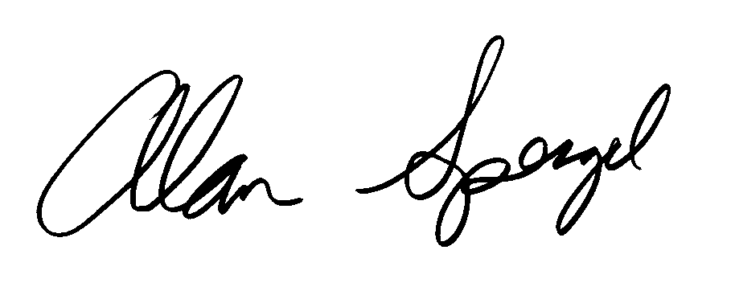

Alan Spergel, B.Comm., CA•CIRP, CFE, CIRP
Chair,

CANADIAN ASSOCIATION OF INSOLVENCY AND
RESTRUCTURING PROFESSIONALS

